Joyful Journeys Baby Lounger – Safety Recall Information

Dear Customer,

This voluntary recall is being conducted in cooperation with the U.S. Consumer Product Safety Commission (CPSC).

The Joyful Journeys Baby Lounger does not meet certain updated federal safety requirements for infant sleep products Due to Risk of Serious Injury or Death from Entrapment and Fall Hazards. No injuries have been reported.
Consumers should immediately stop using the lounger and keep it out of reach of infants.

How to Participate in the Recall:
Please email: joyfuljourneysrecalls@myjoyfuljourneys.com and include the following in your email:
- Full name
- Order number (if available)
- Photos of the destroyed lounger with

Destruction and Photo Instructions:
- Cut the baby lounger fully in half (cover, foam insert, and sleeping pad)
- Place a piece of paper with your name and today’s date
- Take photos of the destroyed lounger with paper and joyful journeys label visible
- Send photos to joyfuljourneysrecalls@myjoyfuljourneys.com to obtain refund

These requirements ensure proper verification and prevent recalled items from being reused or resold.

Products Included in the Recall
This recall includes all patterns and versions of the Joyful Journeys Baby Lounger sold online between December 2023 and October 2025.
Patterns and product photos are shown on the next page are provided to help customers identify affected products.

Contact Information:
For questions or assistance, please email: joyfuljourneysrecalls@myjoyfuljourneys.com

Thank you for your cooperation in this important safety matter.
Joyful Journeys Customer Care

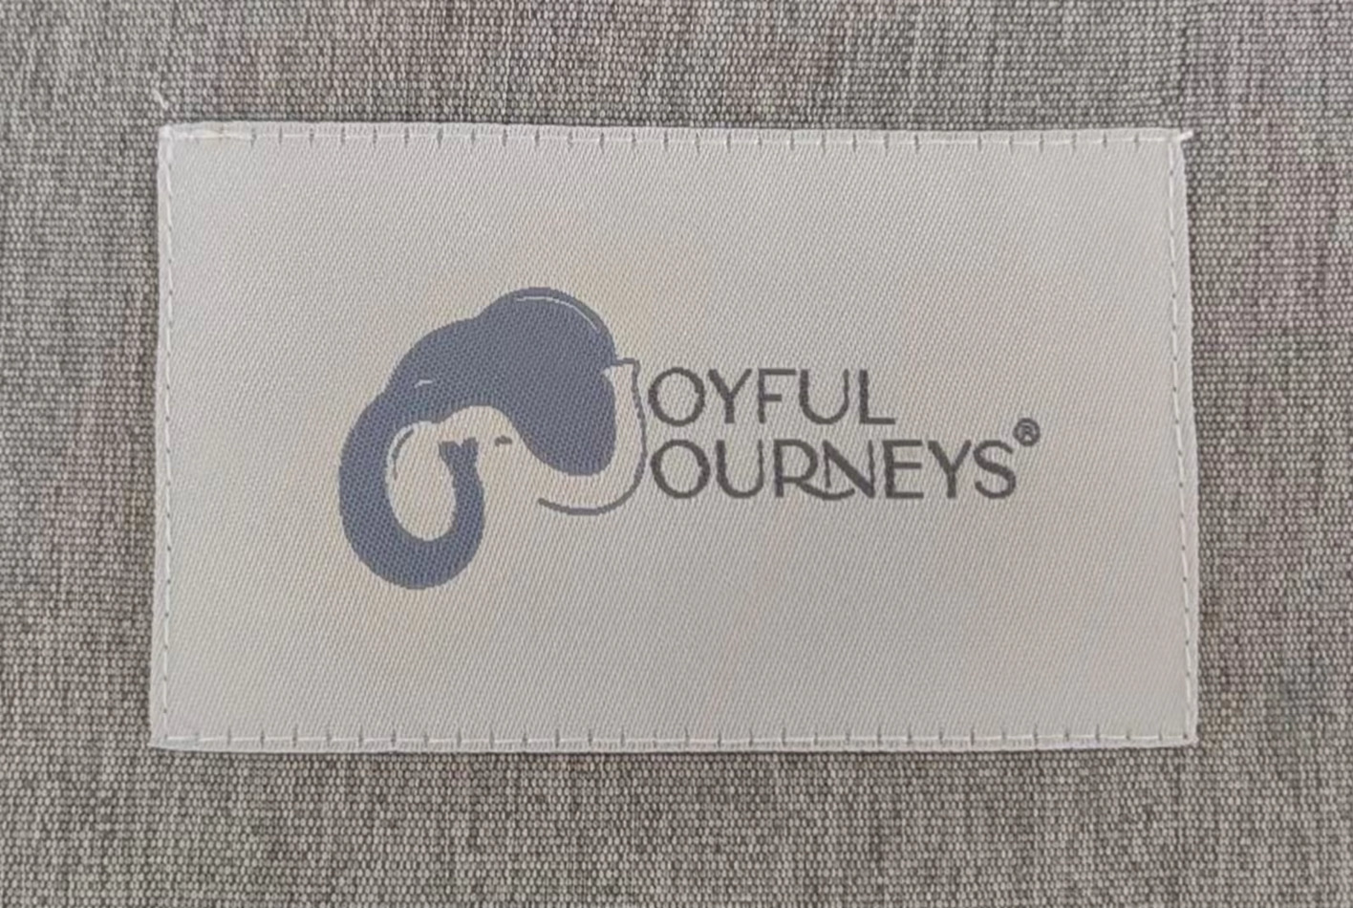
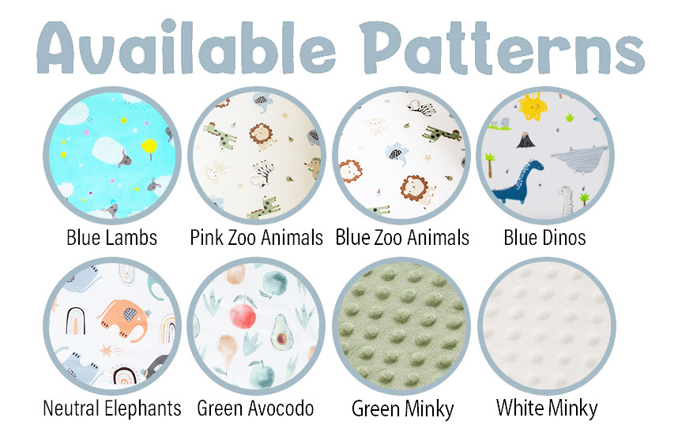
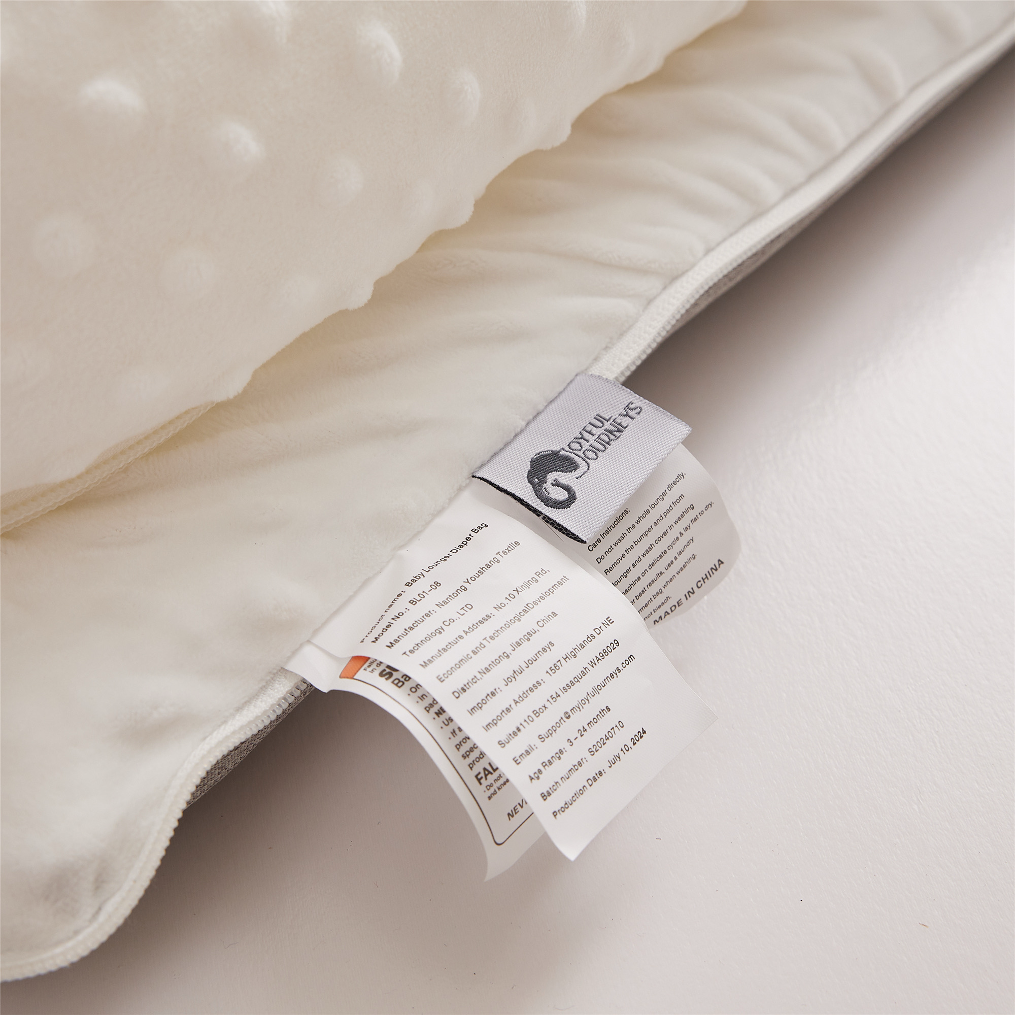
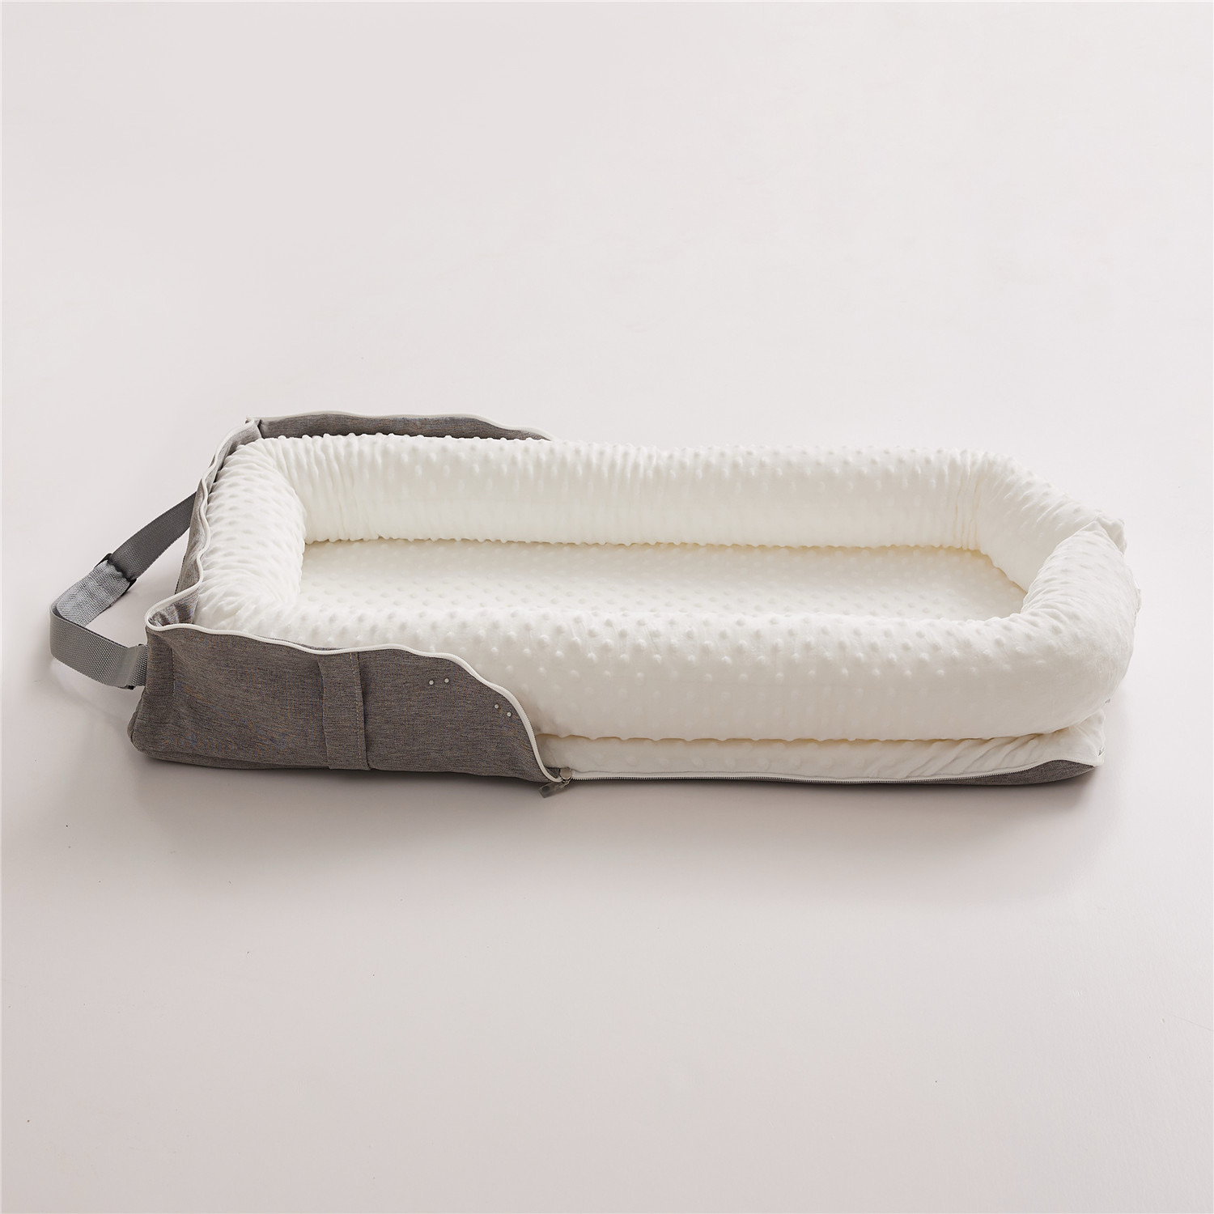
Joyful Journeys Baby Lounger Patterns
